Quantitative Analysis of EtG and EtS in Urine Using Ion Exchange SPE and an Aqueous C18 HPLC Column
Feb 01, 2015
By Jody Searfoss
Special Issues

Ethyl glucuronide (EtG) and ethyl sulphate (EtS) are conjugated ethanol metabolites formed in low amounts in the body following alcohol consumption. EtG and EtS are excreted in urine for a prolonged time (EtG up to 80 h and EtS up to 24 h after ingestion). This makes them valuable, sensitive alcohol biomarkers for complied abstinence.
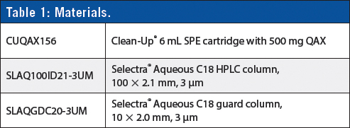

This solid-phase extraction (SPE) method uses a strong anion exchange (QAX) column to extract the acidic EtG and EtS from urine utilizing a single elution for both EtG and EtS that plays to the chemical nature of both analytes.

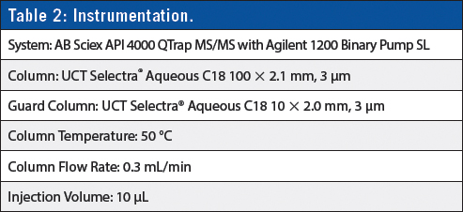

Sample Pretreatment
1. To 0.5 mL of urine sample containing deuterated analogues of EtG/EtS add 4.5 mL of D.I. H₂O.
2. Vortex for 30 s.

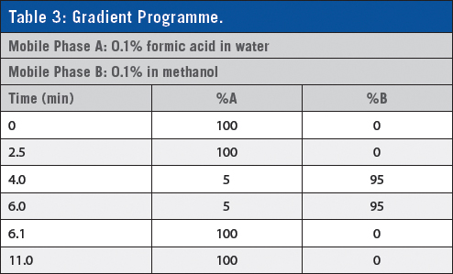

SPE Method
1. Precondition SPE column with 5 mL of MeOH followed by 5 mL of D.I. H₂O.
2. Apply sample to SPE column.
3. Wash SPE column with 5 mL of ACN followed by 5 mL of MEOH.
4. Dry column (10 min at full vacuum or pressure).
5. Elute EtG/EtS with 5 mL of 2% HCl in ACN (collect eluate at 1–2 mL/min).
6. Evaporate to dryness at < 50 °C.
7. Reconstitute sample in 100 μL of D.I. H₂O.

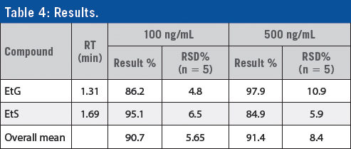

Conclusion
Excellent recoveries were achieved with EtG at 97.9% and EtS at 84.9%. The extraction efficiency was evaluated by fortifying samples at two varying concentrations (100 ng/mL and 500 ng/mL). RSD values were less than 11% (n = 5 at each concentration). Matrix-matched calibration curves were used for quantification with R² values ranging from 0.9983 to 0.9998 over the entire concentration range (50–1500 ng/mL). The limits of detection and quantification for this method were determined to be 25 ng/mL and 50 ng/mL, respectively for EtG and EtS.

UCT, LLC
2731 Bartram Road, Bristol, PA 19007, USA
Tel: (800) 385 3153 E-mail: methods@unitedchem.com
Website: www.unitedchem.com

